Project GitHub Link:
https://github.com/Andran1k/SOSC314_CourseProject

Division of Responsibilities
For this project stage, each group member was responsible for the following components:

Andranik Pambukhchyan
Primary responsibility:
Data source identification and data collection feasibility using the YouTube Data API.
Specific tasks completed this week:
- Implemented a Python script to collect trending YouTube video metadata using the official YouTube Data API (scripts/fetch_youtube_trending.py)
- Configured secure API key handling using a .env file and environment variables
- Generated a sample dataset of trending music videos for feasibility assessment (data/raw/sample_trending_videos.csv)
- Ensured reproducible file paths and project structure
- Drafted and revised the project description in the README file

Asilbek Amonov
Primary responsibility:
Research question formulation and project scope definition.
Specific tasks completed this week:
- Defined the research question focusing on language use in trending music videos
- Determined the unit of analysis and category-based scope (Music only)
- Established inclusion and exclusion criteria for the dataset

Research Question
This project studies the language used in YouTube trending videos, focusing on how creators communicate and frame their content in highly visible spaces. YouTube’s Trending section plays an important role in shaping public attention by highlighting videos that receive widespread exposure. To keep the project focused and manageable, this study concentrates on one content category. Specifically, we focus on Music videos.
The main research question for this project is:
What linguistic themes and patterns appear in the titles and descriptions of YouTube trending music videos?
By limiting the analysis to a single category, we aim to better understand how language is used within a specific cultural domain, rather than comparing across unrelated types of content.

Data Source
The data for this project are collected using the YouTube Data API v3, which is an official, API-based data source provided by Google. We use the videos.list endpoint with the parameter chart=mostPopular, which returns videos currently appearing in YouTube’s Trending section. This project relies entirely on API-based data collection. No web scraping is used. The API provides structured and reproducible metadata for each video.
For each trending music video, the following fields are collected:
- Video title
- Video description
- Video tags (when available)
- Content category ID
- View count, like count, and comment count
- Publication date
- Region code (country)

Unit of Analysis
The unit of analysis for this project is one YouTube trending music video.
Each observation corresponds to a single video that appears in the Trending section and is labeled by YouTube as belonging to the Music category. This unit of analysis allows us to treat each video’s title and description as a single text document for analysis.

Scope, Inclusion, and Exclusion Decisions
For the Week 2 feasibility assessment, we collected a sample of trending music videos from the United States region.
Inclusion criteria:
- Videos must appear in YouTube’s Trending section
- Videos must be labeled as belonging to the Music category
- Videos must have a non-empty title
- Videos must be returned by the official YouTube Data API
Exclusion criteria:
- Videos outside the Music category
- Non-trending videos
- Videos with missing or empty titles
- Video comments (excluded at this stage)
The decision to focus only on the Music category was made to allow more detailed analysis of linguistic patterns within a single domain.

Initial Data Exploration and Feasibility
An initial exploratory analysis was conducted using a Python script that loads the raw CSV data generated by the YouTube Data API collection script.
The exploratory analysis included:
- Counting the number of videos in the sample
- Checking for missing values in titles and descriptions
- Measuring the length of titles and descriptions
- Inspecting example titles and descriptions manually
The results of this exploration show that:
- All sampled videos contain titles, and the majority contain non-empty descriptions
- Titles are short but informative, while descriptions are substantially longer, providing enough text for text-as-data methods
Several example titles and descriptions were reviewed to confirm that the text is meaningful and suitable for further analysis.
Figure 1 presents a basic summary of the sample and illustrates the number of trending music videos included in the initial dataset.
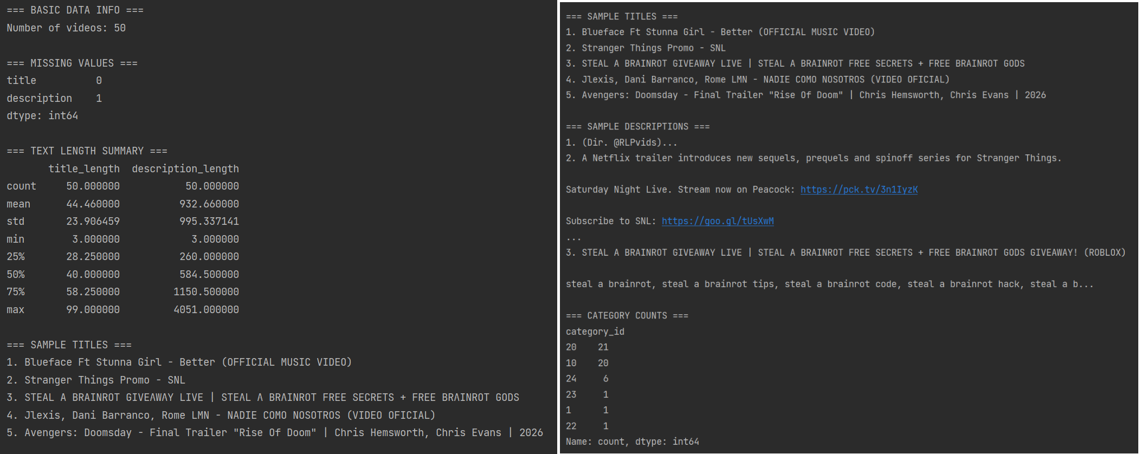
Figure 1

Data Feasibility Assessment
The initial sample confirms that the data are well-suited for this project. The YouTube Data API provides reliable access to trending music video metadata, and the text fields (titles and descriptions) contain sufficient information for analysis.
Because the data collection process is automated and reproducible, it is feasible to expand the dataset in later weeks by:
- Collecting more trending music videos
- Extending data collection over multiple time points
- Including additional regions if needed
Overall, the data are accessible, sufficiently large, and appropriate for applying text-as-data methods such as word frequency analysis and topic modeling in later stages of the project.

